**Sub Queries**

* A subquery is a SQL query within a query.
* Subqueries can return individual values or a list of records.
* Subqueries must be enclosed with parenthesis.
* These subqueries can reside in the WHERE clause, the FROM clause, or the SELECT clause.
* There is no general syntax; subqueries are regular queries placed inside parenthesis.
* You can nest subqueries up to 32 levels.
* Subqueries can be used with the following SQL statements along with the comparison operators like =, <, >, >=, <= etc.
* It should be very clear that, a subquery is simply a select statement, that returns a single value and can be nested inside a SELECT, UPDATE, INSERT, or DELETE statement.

Most often, the subquery will be found in the WHERE clause. These subqueries are also called **nested subqueries**.

1. **SELECT column-names**
2. **FROM table-name1**
3. **WHERE value IN (SELECT column-name**
4. **FROM table-name2**
5. **WHERE condition)**

A subquery can also be found in the SELECT clause. These are generally used when you wish to retrieve a calculation using an aggregate function such as the [SUM](https://www.techonthenet.com/sql_server/functions/sum.php), [COUNT](https://www.techonthenet.com/sql_server/functions/count.php), [MIN](https://www.techonthenet.com/sql_server/functions/min.php), or [MAX](https://www.techonthenet.com/sql_server/functions/max.php) function, but you do not want the aggregate function to apply to the main query.

1. **SELECT column1 = (SELECT column-name FROM table-name WHERE condition),**
2. **column-names**
3. **FROM table-name**
4. **WEHRE condition**

A subquery can also be found in the FROM clause. These are called **inline views**.

1. **SELECT column-names**
2. **FROM table-name1,**
3. **(SELECT column-name**
4. **FROM table-name2 group by column-names) AliasName**
5. **WHERE condition**

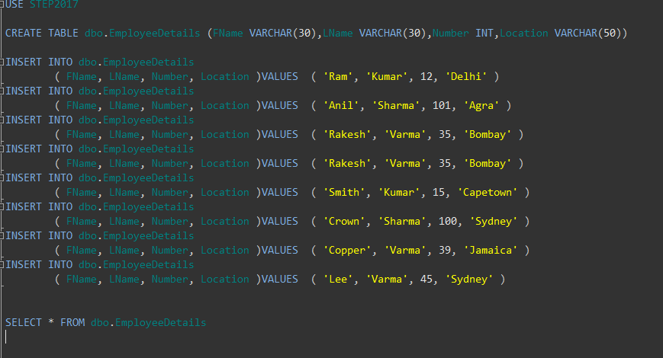

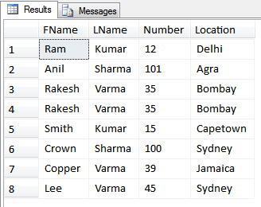

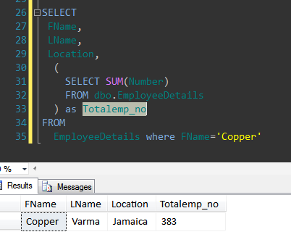

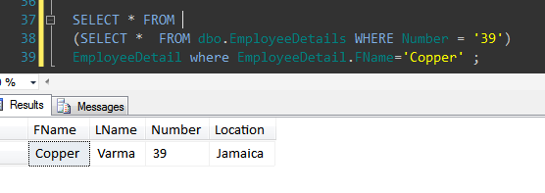

You can construct a WHERE Clause with a subquery. We can use the following operators with Subquery.

* comparison operator
* IN operator
* ANY or All operator
* EXISTS function

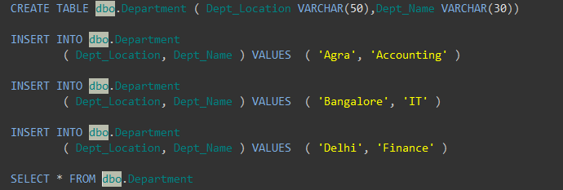

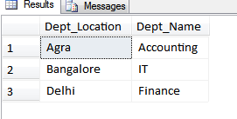

**Subquery and Comparison operator**

This example shows the simple subquery that is used with the operator =.

The following query determines the first name and last name of the employee with the operator =.

select emp_fname,emp_lname from EmployeeDetail where emp_add =(select dept_add  from dept wheredept_name ='finance')

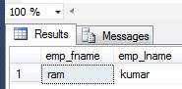

**Subquery and in operator**

This example shows the simple subquery that is used with the IN operator:

select * from EmployeeDetail where emp_add IN(select dept_add from dept where dept_name='finance')

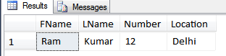

**Subquery and ANY** **operator**

The ANY operator evaluates to true if the result is an inner query containing at least one row that satisfies the comparison.

select emp_fname,emp_no from EmployeeDetail where emp_add >any(select emp_add from EmployeeDetail );

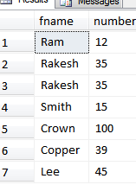

**Subquery and ALL operator**

The "ALL"Operator evaluates to true if the evaluation of the table column in the inner query returns all the values of that column.

select emp_fname, emp_no from EmployeeDetail where emp_add <=all(select emp_add from EmployeeDetail);

